Report for research interest development

Name: Yihong Wu Date: 20180820

Report for Research Interest Development

1. **Research question(s):**

What are the differences in cellular morphology throughout the cycle of cells (cell type: __________), measured by the new technique “Biotech High Content”? How to use the new technique to investigate questions by measuring cellular morphological phenotypes?

1. **Why is this question(s) important? (Novelty? Significance?...)**

To investigate the difference in morphology of cell throughout its cycle, building a systemic platform for its later experiments.

1. **How will this research advance the related field?(The anticipated results and contribution…)**

There is no platform built up for recording cellular parameters of interest by measuring cellular morphological phenotypes, so building up a system is important.

1. **What approach will you take? (Research plan, experimental materials and methods…)**

“Cell morphological phenotypes, including cell shape, size, intensity , and texture of cellular compartments have been shown to change in response to perturbation with small molecule compounds.”(Nassiri & McCall, 2018) In the study of Nassiri, they use *CellProfiler* to transform images to quantitative information.

In this study, we are to use “Biotech *High Content*” to quantify the phenotypes of cell morphology. (The technique is to be demonstrated by Biotech on ________)

**Below is a graphical summary of RNAi morphological profiling on genes as components of known pathways** (Collinet et al., 2010; Hayer & Meyer, 2010):

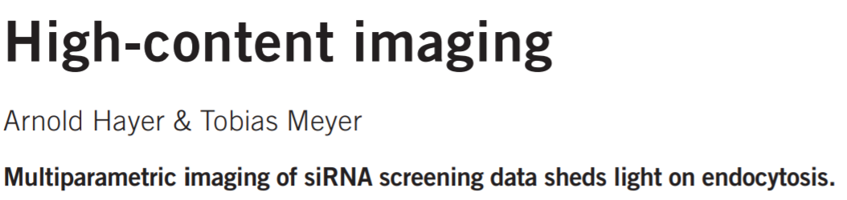

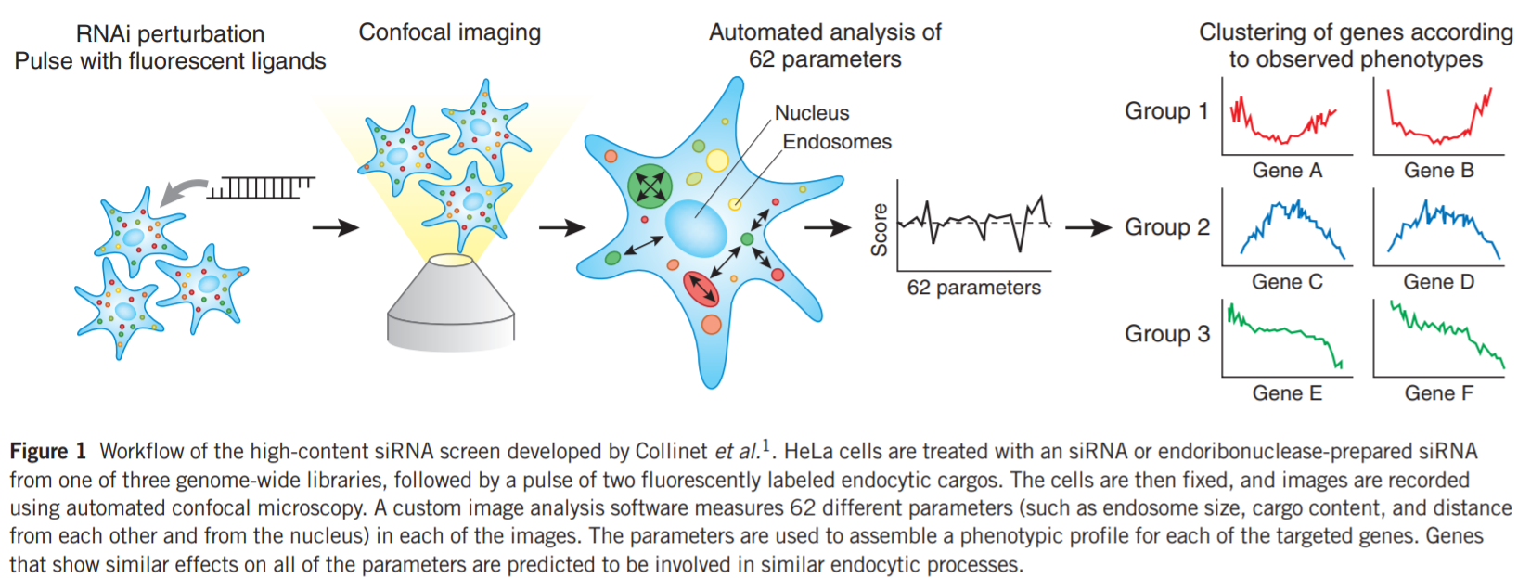

Similar to Collinet’s research, we could generate phenotypic profiles for genes of interest, clustering genes with the profiles of parameters. Also, we could develop profiles along the cell cycle for cell grouping.

**Graphical summary of *cell morphology enrichment analysis* (linking transcriptomic changes with alterations in morphology) (Nassiri & McCall, 2018):**

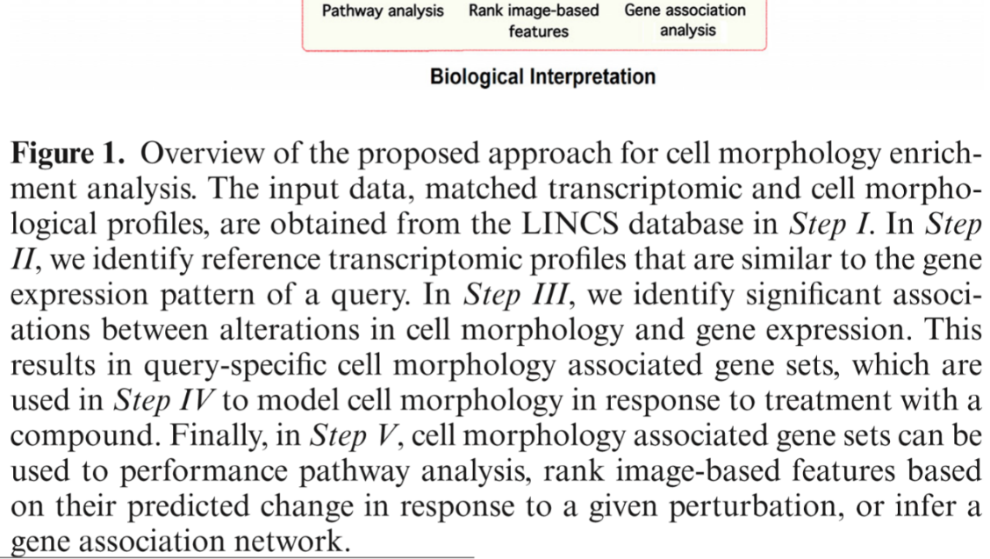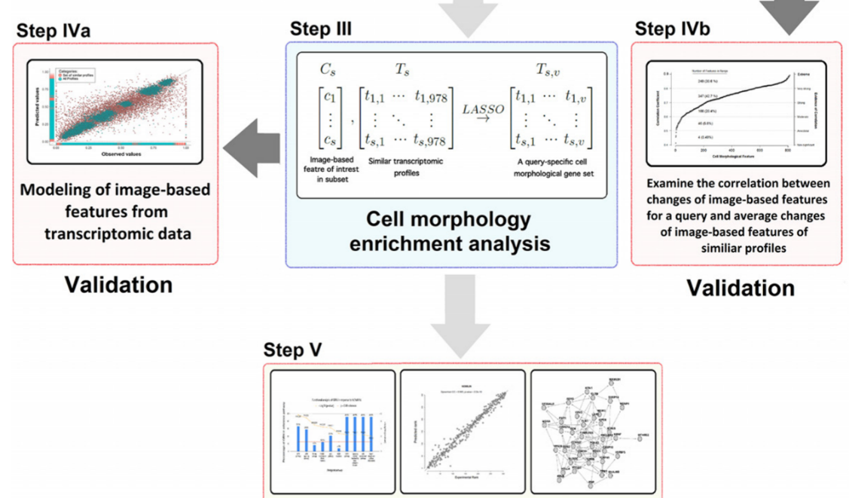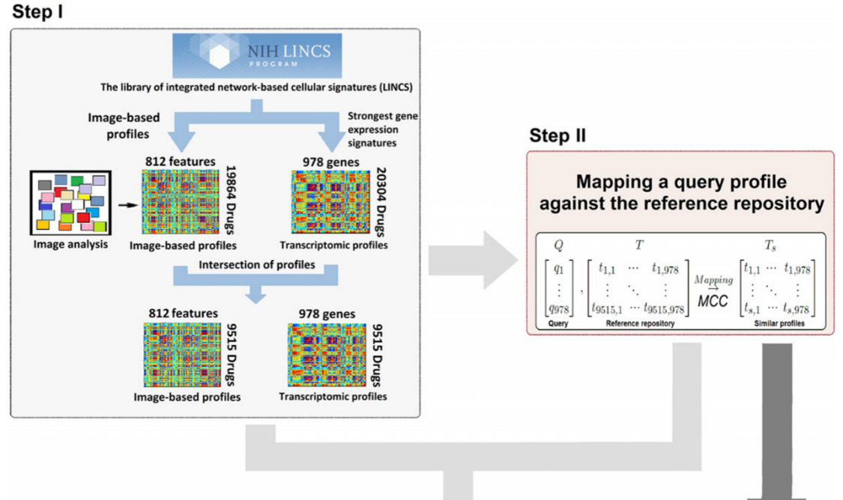

**Graphical summary of image-based cell profiling (Caicedo et al., 2017)**

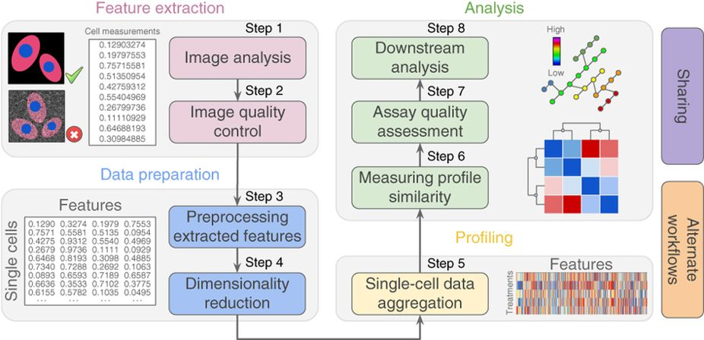

1. **What kind of help will you need? (Collaborator? Core facility? If any, what are their roles and function?)**

Biotech’s demonstration, Chui-hua Lin, CT Chao.

**References**

Caicedo, J. C., Cooper, S., Heigwer, F., Warchal, S., Qiu, P., Molnar, C., . . . Carpenter, A. E. (2017). Data-analysis strategies for image-based cell profiling. *Nature Methods, 14*, 849. doi:10.1038/nmeth.4397

Collinet, C., Stoter, M., Bradshaw, C. R., Samusik, N., Rink, J. C., Kenski, D., . . . Zerial, M. (2010). Systems survey of endocytosis by multiparametric image analysis. *Nature, 464*(7286), 243-249. doi:10.1038/nature08779

Hayer, A., & Meyer, T. (2010). High-content imaging. *Nature Biotechnology, 28*, 424. doi:10.1038/nbt0510-424

Nassiri, I., & McCall, Matthew N. (2018). Systematic exploration of cell morphological phenotypes associated with a transcriptomic query. *Nucleic Acids Research*, gky626-gky626. doi:10.1093/nar/gky626